Little SPARK: Simple Play Adaptations to Reference for Kids

SuperTalker FT
Description: | Image:
The SuperTalker FT is multiple message static display augmentative and alternative communication (AAC) speech device that can assist children who need speech support throughout their daily activities. | 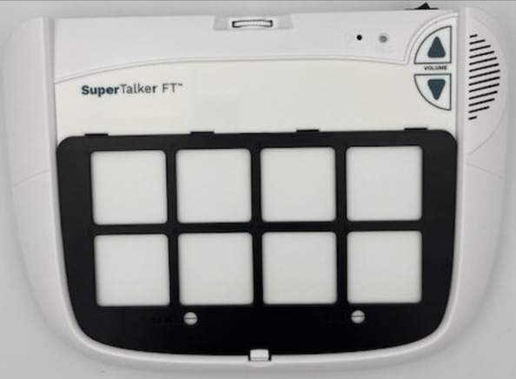

Who Might Benefit?
Those who have communication challenges, struggle to express themselves, understand oral directions, and complete multi-step tasks, often leading to frustration and social difficulties.

Why Use?
Provides an opportunity to communicate more effectively, engage in shared exchanges, understand verbal directions with visual cues, and make choices.
Instructions for Use: | Adaptation Ideas:
Environmental Considerations  - Easily use in almost any environment, easily transportable due to small size, weight (33.6-oz).  Positioning & Alternate Positioning  - Use in any position; seated, standing, on the floor, with a slanted surface.  Basic Play/Use  - Record messages, words, phrases, sentences relevant to the child’s immediate activities. | Simplify It  - This device can be made more simplistic by using the 1 message cell frame included as an option for the device  Stabilize It  - The SuperTalker FT could be velcroed or placed of Dycem nonskid matting on most any surface to help stabilize it so it doesn’t move away when the child tries to activate the button.  Add Sensory Cues  - Sensory cues could be added to the activation button such as puffy stickers, puffy paints, different textures.  DIY Alternatives  - Paper communication systems can be used when speech generating devices are not available or are not appropriate for the activity (e.g. water play where exposure to moisture may damage the device, loud environments where the speech generated by the device cannot be heard, etc.).

